Updated Use Cases

Actors
- User – an individual tracking personal finance.

Use-Case Diagram

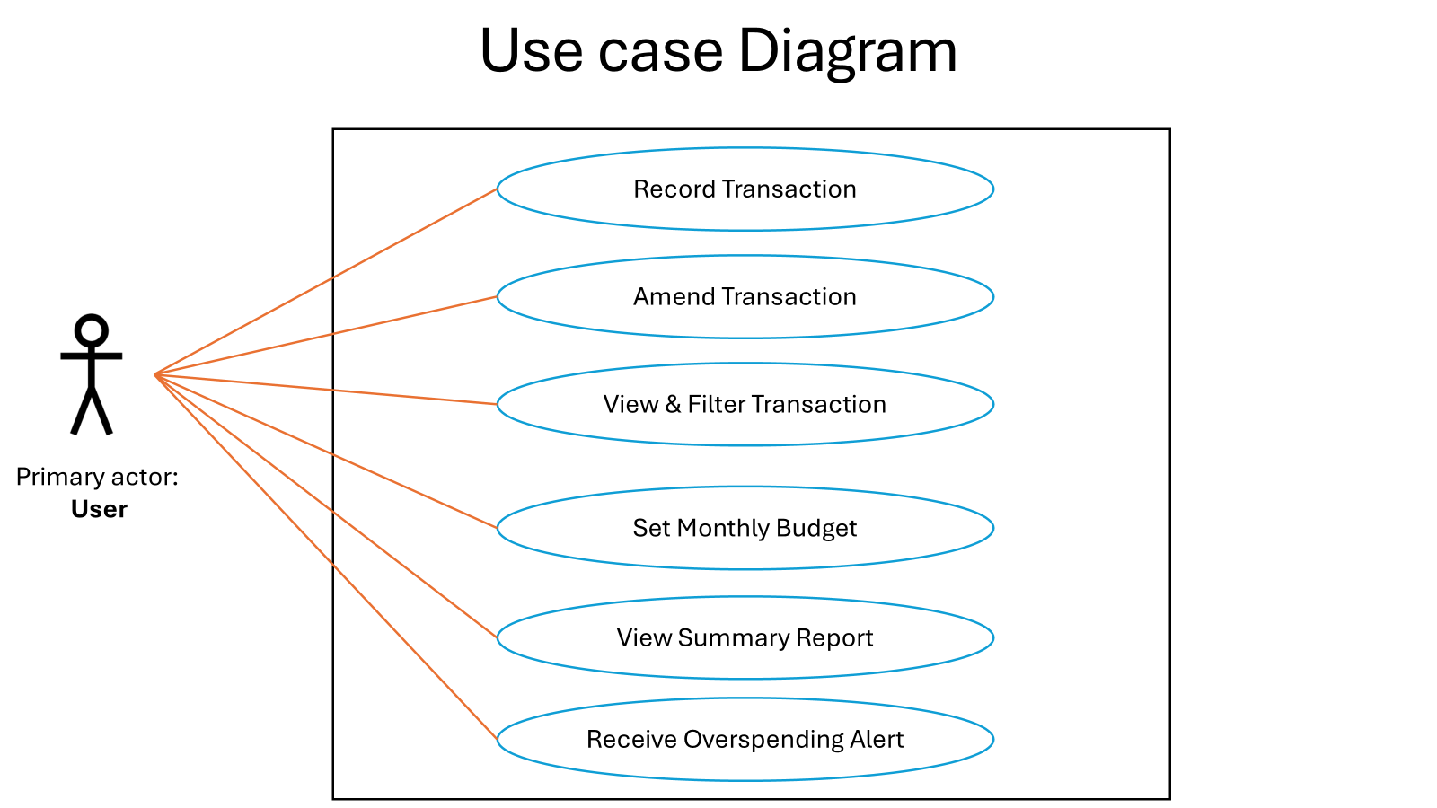

Use-Case Descriptions

UC-1: Record Transaction
- Actor: User
- Goal: Add a new income or expense.
- Preconditions: App is running.
- Main Flow: (1) User initiates adding a transaction. (2) System asks for type, amount, date, category, optional note. (3) User confirms. (4) System saves and updates totals.
- Alternates: Missing/invalid fields → system requests correction.
- Postconditions: Transaction is persisted; summaries reflect it.

UC-2: Amend Transaction
- Actor: User
- Goal: Modify or delete an existing entry.
- Preconditions: At least one transaction exists.
- Main Flow: (1) User selects a transaction. (2) System shows details. (3) User edits or deletes. (4) System saves and refreshes totals.
- Alternates: Entry not found → system informs user.
- Postconditions: History and aggregates reflect the change.

UC-3: View & Filter Transactions
- Actor: User
- Goal: Review past entries by period/category.
- Main Flow: (1) User requests transaction list. (2) System displays entries. (3) User applies filters. (4) System narrows results and updates totals for the selection.
- Alternates: No matches → show empty results and zero totals.

UC-4: Set Monthly Budget
- Actor: User
- Goal: Define or adjust a per-category spending limit for the current month.
- Main Flow: (1) User selects category. (2) System requests limit. (3) User confirms. (4) System stores limit and shows remaining allowance.
- Alternates: Invalid limit → system asks for a valid amount.
- Postconditions: Budgets available to alerts and reports.

UC-5: View Summary Report
- Actor: User
- Goal: See totals and category breakdowns for a period.
- Main Flow: (1) User selects a period. (2) System computes totals and breakdown. (3) System presents figures and at least one chart.
- Alternates: No data in period → system shows zeros and a note.

UC-6: Receive Overspending Alert
- Actor: User
- Goal: Be notified when a category exceeds its limit.
- Preconditions: At least one budget is defined.
- Main Flow: (1) System compares spending to limits as transactions are added/viewed. (2) System signals when a limit is reached or exceeded.
- Alternates: No budgets defined → no alert.
- Postconditions: User is aware of budget status.

